The Digital Actor Hologram Performance Project: Achieving the Photorealistic Facial Skin and Rendering

Jiang Hai Tao*, Ji Yun*, Tae Soo Yun**

*Graduate School of Visual Contents, Dongseo University,
47 Jurye-ro, Sasang-gu, Busan 47011, Korea
jiang5275@gmail.com, jiyunmyself@naver.com
**Division of Digital Contents, Dongseo University,
47 Jurye-ro, Sasang-gu, Busan 47011, Korea
yntaesoo@gmail.com

Abstract

As the first step in a digital actor hologram performance project, this paper proposes a lighting design and workflow for high-quality texture source in digital human character skin animation.
For cost-effectiveness, paper has been attached to a cylindrical jig in order to diffuse direct light and achieve consistent images. To generate a geometric model of a face, Artec 3D scanner was used to obtain a face model which was then cleaned up and processed using Zbrush.
Using the method proposed in this paper we have been able to produce high-quality facial modeling and texture information at low cost, with less lighting influence.

Keywords: Animation; Digital Actor; 3D Scan; Photorealistic Rendering

I. Introduction

Creating realistic, animatable human face models is one of the most difficult challenges that have long continued in computer graphics. In particular, characterizing the facial geometry, facial reflectance properties and facial expressions presents some of the most critical issues. Of these, capturing facial geometry has now become more common, thanks to commercially available tools such as Cyberware which is capable of extracting information to the millimeter. [1]
However, it is still difficult to accurately capture the reflectance characteristics of a changing face. In particular, the method of mapping the texture of facial photograph onto a geometric model makes it very difficult to achieve realistic expression in line with changes in light, view point and facial expressions. This is because the reflectance characteristics of a face are complex and the surface of a face has both diffuse and specular elements. [2, 6] .
In order to achieve realistic face expression, obtaining high-quality texture source, with the aid of lighting or viewpoint, is just as important as good shader design for rendering.
This project aims at a digital actor hologram performance. As its first step, in order to obtain high-quality texture source for facial animation of digital human character, this paper proposes a new method of lighting design and work flow. First, for get consistent facial texture, we experimented with LED lighting stage to get 3 images (front view and side views) as in Fig. 2. While there are various methods for consistent imaging, this experiment attached paper to a cylindrical jig to diffuse direct light as a cost-effective way of achieving consistent image.
In order to generate facial geometry, Artec 3D scanner was used to obtain a face model which was then cleaned up and processed using Zbrush to produce face model.
Using the proposed method we are able to produce high-quality facial modelling and texture information which is less affected by lighting, and do so at low cost.
The paper proceeds as follows. In the following section, an overall workflow of facial animation for digital character performance is explained. Then, lighting device for consistent facial texture is described in detail. In Section 3, we describe building the digital character from the scan instrument and realistic real-time head rendering in the game engine. The paper ends with an explanation of results and conclusion.

II. Acquiring Realistic Facial Scan and Capturing Facial Skin

Fig. 1 illustrates the overall process of obtaining and rendering realistic facial geometry and facial texture as a first step in the project (digital actor hologram performance).
A key objective of this study is to capture high-quality facial texture that is less influenced by lighting, viewer or any type of facial expression. Using a lighting mapped onto a semi-sphere, 3 facial images were used for generating facial texture.

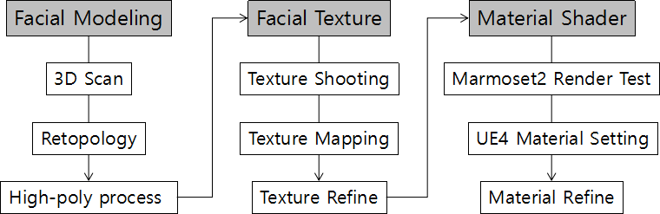

Fig. 1 The Schematic Diagram of Our Method

This section describes lighting device for facial texture capturing and the processing of captured image. Also, reflectance model which is projected from the lighting device to the surface of face is also presented.

A. The Lighting Stage

The lighting device used in this experiment to capture facial texture is as shown in Fig. 2. The lighting stage consists of LED lighting set, which has paper attached to diffuse LED light, and a Canon 5D DSLR camera. The LED lights are, as shown in the diagram, 12 spot LEDs in 2x1 arrangement; two such light sets are placed on a cylindrical stand. The distance between the object of imaging, the face, and the lights is approximately 105cm. The camera looks directly into the face.
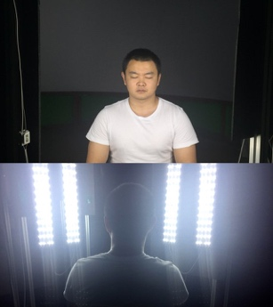 | 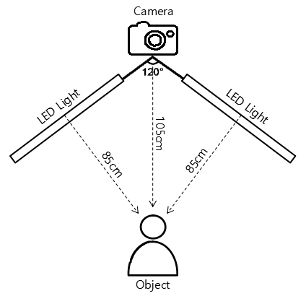
(a) Actual shooting | (b) schematic diagram of lighting stage
Fig.2 The Lighting Stage

Fig. 3 shows the result of consistent texture capture using the proposed lighting system. Except for some specular elements in the forehead, the captured texture was mostly consistent.

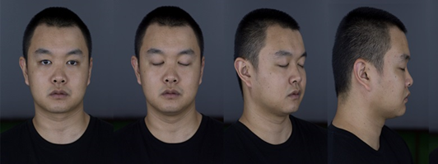

Fig. 3 The Source of Facial Texture

III. Building the Digital Character from the scan and Rendering the Face

In order to verify the utility of texture information obtained in this experiment, a facial geometric model was obtained using 3D scanner (Artec Eva). For consistency in geometric information, the same lighting conditions were used as facial texture capturing.

A. 3D Scan & Pre-processing

Even if facial scanning is accurate and detailed, pre-processing is required for the data to be used in real-time engine. Many meshes have irregular boundaries and mesh artifacts come to be found around eyes and mouth.These defects need to be processed one by one.
Fig. 4(a) is 3D scan data which has, as mentioned above, much redundancy and ambiguity. This was cleaned using commercially available ZBrush tool. The number of polygons after clean-up, as in Fig.4(b) was approximately 2 million; after optimization with Maya Retopology in Fig. 4(d), this fell to approximately 7,000 (=6991).

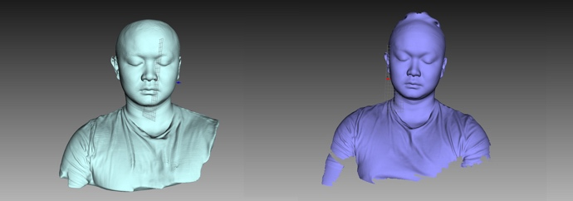
(a) 3D Scan Data
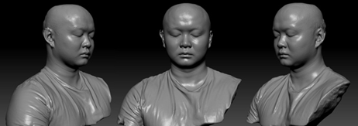
(b) ZBrush Screenshot
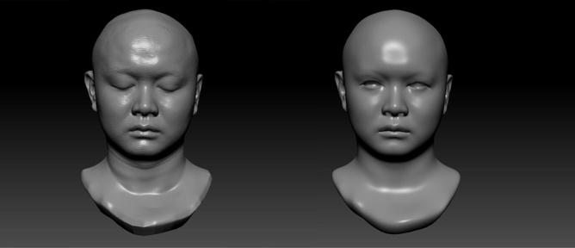
(c) Zbrush Modeling Refine
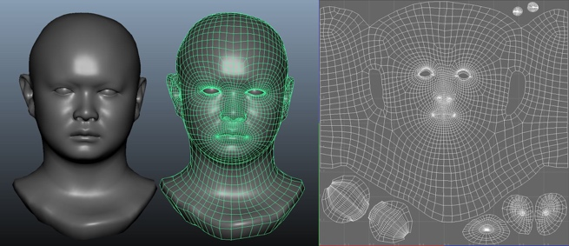
(d) Maya Retopology and UV

Fig. 4 3D Scan & Pre-processing

B. Texture Mapping and Shading

As shown in Fig. 3, using obtained facial photograph to map texture on to facial geometry proceeds as follows. First, as in Fig. 5(a), Zbrush Spotlight is used to produce diffuse texture; Photoshop is used to refine texture source into 4096*4096 size. Then, as in Fig. 5(b), in order to maintain the detail of high-poly modelling and diffuse texture, high-quality diffuse texture is used for conversion into mask texture. In high-poly production, mask texture is used to express details such as skin, wrinkles and pores accurately and rapidly. Since the final goal of this study is to use real-time 360-degree VR video in real-time engines like Unity and Unreal Engine rather than CGI-based rendering, real-time shader is of great importance.

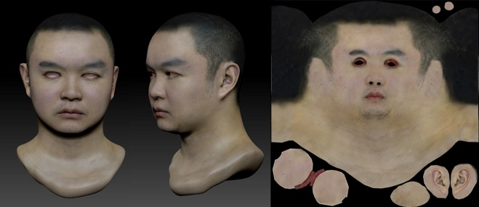 | 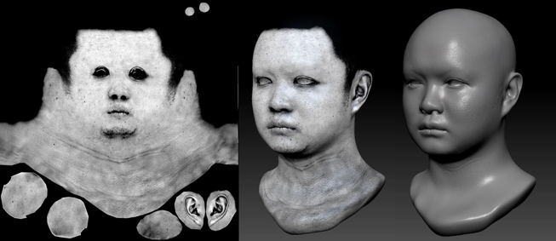
(a) Using ZBrush Spotlight to produce Diffuse texture, Refine in Photoshop (4096*4096) | (b) Zbrush High-Poly Steps: Diffuse Texture-> Mask Texture, -> High-Poly Production
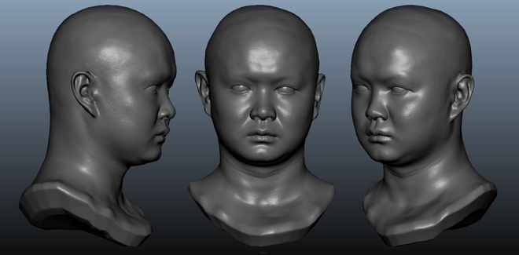 | 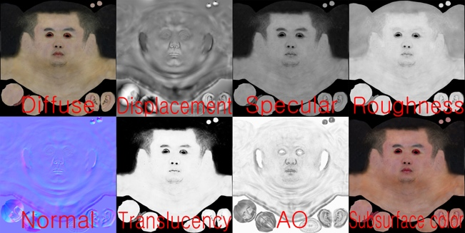
(c) Maya Modelling Optimization | (d) Texture (4096*4096)
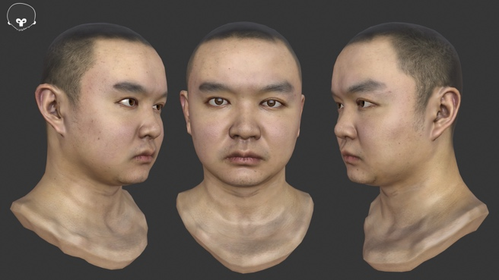 | 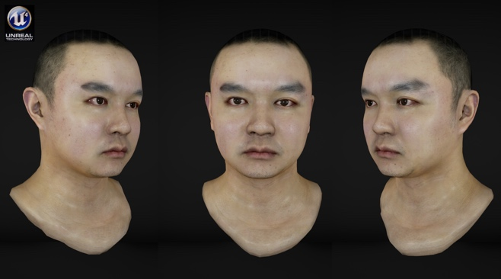
(e) Shading Test: Marmoset Toolbag 2 | (f) Final Rendering with Shader in Unreal Engine
Fig. 5 Texture mapping and shading process

Thus the present study constructs normal. AO, displacement, diffuse, specular, translucency, cavity, and subsurface color map sources as in Fig. 5 (d). Each map source is tested using Marmoset Toolbag 2 the results are shown in Fig. 5(e). Real-time shader of head is used for test in Unreal Engine, yielding the final rendering images shown in Fig. 5(f).

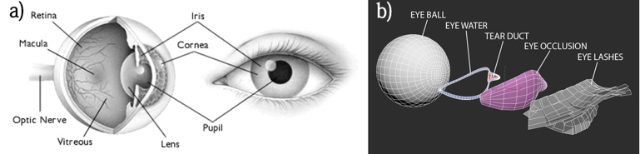
(a) Schematic of the human eye
(b) The dispersed structure of a generic CG eye
Fig.6 The Structure of the Human eye and CG eye

Eyes are the most impressive features in the human face; modeling must pay special attention to getting the eyes right. as the eyes have such decisive impact on one’s impression, facial Eyes in real images show strong light causing diffraction with eyeball. For realistic expression of the eye through CG, Fig. 6 shows the anatomy of the human eye; although it may seem simple in structure, it difficult to achieve realistic expression of the eye in CG.
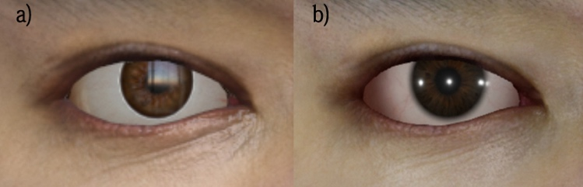

Fig. 7 Eye shader comparison

Thus we tried to cross the uncanny valley to make a more realistic CG character in real-time 3D engine. As in Fig. 7(a), issues such as iris depth diffuse, caustics, and looking fake and flat were addressed by making deep inverted iris and modifying caustics (b).
Fig. 8 shows shader for rendering in real-time engine material shader consists of 7 elements (Diffuse, Specular, Roughness, Opacity, Subsurface Scattering, Normal, and Displacement). In diffuse element, diffuse texture produced from photographic sources can be used to express the base colour of the character and create realistic skin expression.
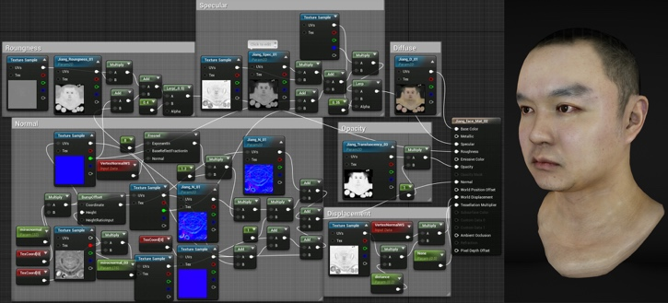

Fig. 8 Material Shader

In specular element, specular texture and AO texture are connected and set in vector to adjust the specular intensity of the skin. Specular value is set at 0.35; this figure is obtained by converting real-world specular value into the range used in engine. In roughness element, roughness texture is used as base for adding vector or scalar control to adjust the luminosity of the skin. For opacity, input controls the degree of subsurface scattering. Pure white results in maximum subsurface scattering; pure dark had no subsurface scattering. In subsurface scattering, subsurface profile is used for setting; subsurface profile uses a rendering approach based on subsurface scattering. This is particularly useful for the expression of the subcutaneous as in the ears. In normal element, with normal texture obtained from high-poly modelling as base, 3 layers of pore-detail normal texture, obtained from multiplying scalar parameter to TexCoord material expression, were added to enable pore details in the final rendering. In displacement, Vertex NormalWS expression and vector or scalar control were added to displacement texture to enrich the form of modeling.

C. Discussion and Future Work

<Table 1> Digital Actor processing time

Process | Resources
Scanning the Human Face | 2 hours total
Scan Processing (Zbrush, Retopology, Maya refine) | 2 days, 2 processed scans, 1 artist
Capturing the Face Skin | 2.5 hours total
Texture Source | 2 days, 8 textures, 1 artist
Shading Process | 2 days, 2 material shaders,  1 artist

Table 1 shows time taken for facial modeling and shading for digital hologram project, the ultimate goal of the present study.
This project has been a great learning experience which has led to a digital actor development process which proposes a cost-effective character development method. Based on such digital actor development project, the below five development processes are proposed for the development of photorealistic digital actor.
1. Development of device to minimize the impact of lighting on facial geometry and scanning process
2. Post-scan refine process using commercial tool
3. Facial texture production to get photorealistic face skin
4. Mapping source production after facial test production
5. Shader development for face rendering in real-time engine.
These processes may have somewhat lower quality than the cases [3], [4], [5] for devices and methods for producing diverse facial expressions as described in digital actor development project in the present study USC, but they can be easily applied to project research on utilizing digital character both in academia and in industries.

IV. Conclusion

This paper presents the first step in digital actor hologram performance project; lighting and workflow for high-quality texture source for the facial animation of digital human character.
For consistent facial texture, this experiment devised two sets of LED lighting which have 2 rows of 48 LED lights in total. Technology used in this experiment is more economic than other existing devices and yet produces consistent facial geometry and texture information.
In addition, this research has served to establish a series of processes required for real-time rendering and animation of digital actor; the pipeline proposed should aid academic and industrial research into digital character development. The next step in digital actor hologram performance project is markerless facial motion capture and fur simulation.

References

[1] Tim H., Andreas W., Chris T., Andrew G., Fredrik G., and Paul Debevec, "Animatable Facial Reflectance Fields", Eurographics Symposium on Rendering 2004, pp. 309~320
- Smithsonian Digitization Program Office and USC Institute for Creative Technologies, "Scanning and Printing a 3D Portrait of President Barack Obama", SIGGRAPH 2015 Studio Talks
- Paul Graham, Graham Fyffe, Borom Tunwattanapong, Abhijeet Ghosh and Paul Debevec, "Near-Instant Capture of High-Resolution Facial Geometry and Reflectance", ICT Technical Report No. ICT-TR-01-2015, May, 2015
- Paul Graham, Borom Tunwattanapong, Jay Busch, Xueming Yu, Andrew Jones, Paul Debevec, and Abhijeet Ghosh, "Measurement-Based Synthesis of Facial Microgeometry", EUROGRAPHICS 2013, Volume 32 (2013), Number 2
- Infinite Realities, "UE4 skin shader and virtual character rendering", March 28, 2016 link: http://ir-ltd.net/ue4-skin-shader/
- Paul Debevec, Tim Hawkins, Chris Tchou, Haarm-Pieter Duiker, Westley Sarokin, and Mark Sagar, "Acquiring the Reflectance Field of a Human Face", Siggraph 2000 Conference Proceedings. pp. 1~11
- Pascal Bérard, Derek Bradley, Maurizio Nitti, Thabo Beeler, Markus Gross, ACM Transactions on Graphics (TOG) - Proceedings of ACM SIGGRAPH Asia 2014 TOG Homepage Volume 33 Issue 6, November 2014 Article No. 223

